
14001 Weston Parkway, Suite 106
Cary, NC 27513
(919) 941-9999 | (919) 474-3152 fax | www.kryosphere.com

CLIENT INFORMATION WORKSHEET

Client Name |  |  |  |  |  |  | Date
Physical Address |  |  |  |  |  | Billing Address/Invoice To
City |  |  |  |  |  | City
State |  |  | Zip Code |  |  | State |  |  | Zip Code
Primary Contact Name/Title |  |  |  |  |  | Billing Contact Name
Telephone # (Office) |  |  |  |  |  | Telephone #
Telephone # (cell) |  |  |  |  |  | Email Address
Email Address |  |  |  |  |  | Purchase Order No
Invoices will be emailed to the Email Address(es) above unless other instructions provided below:
Please provide a brief description of biological and/or other material being relocated by Kryosphere:
For Controlled Temperature Freezer Relocations

Freezer Brand #1 |  |  |  |  | Freezer Brand #2
Current Temp Setting |  |  |  |  | Current Temp Setting
Electrical Requirements | 110/115v or 208/220v |  |  |  | Electrical Requirements |  | 110/115v or 208/220v
Upright or Chest Style |  |  |  |  | Upright or Chest Style
Size – cubic feet |  |  |  |  | Size – cubic feet
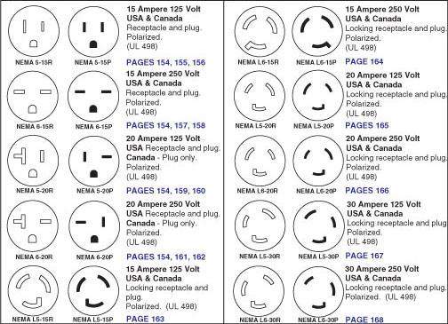 |  |  |  |  | 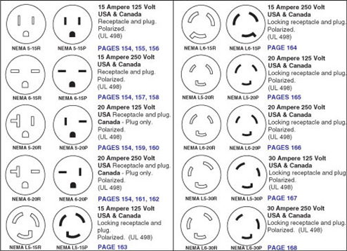
Circle the Plug Receptacle that looks most like your freezer |  |  |  |  | Circle the Plug Receptacle that looks most like your freezer
Freezer Brand #3 |  |  |  |  | Freezer Brand #4
Current Temp Setting |  |  |  |  | Current Temp Setting
Electrical Requirements | 110/115v or 208/220v |  |  |  | Electrical Requirements |  | 110/115v or 208/220v
Upright or Chest Style |  |  |  |  | Upright or Chest Style
Size – cubic feet |  |  |  |  | Size – cubic feet
Circle the Plug Receptacle that looks most like your freezer |  |  |  |  | Circle the Plug Receptacle that looks most like your freezer
Freezer Brand #5 |  |  |  |  | Freezer Brand #6
Current Temp Setting |  |  |  |  | Current Temp Setting
Electrical Requirements | 110/115v or 208/220v |  |  |  | Electrical Requirements |  | 110/115v or 208/220v
Upright or Chest Style |  |  |  |  | Upright or Chest Style
Size – cubic feet |  |  |  |  | Size – cubic feet
For additional freezers, please copy this page and complete
Origination Information (location of freezers) |  |  |  |  | Final Destination Information
Physical Address |  |  |  |  | Physical Address
Floor # |  |  |  |  | Floor #
Raised Loading Dock (Y/N) |  |  |  |  | Raised Loading Dock (Y/N)
Elevator (Y/N) |  |  |  |  | Elevator (Y/N)
Elevator weight limit (lbs) |  |  |  |  | Elevator weight limit (lbs)
Freezers containing client material, will client ensure all materials are secure in freezer or do you need Kryosphere to pack them securely (additional charges may apply)?

